Session 1 Outline: Terraform Installation
1. Pre-requisites for Terraform Installation
- Supported operating systems (Windows, macOS, Linux)
- Tools to be installed:
  - Text editor (e.g., Visual Studio Code)
  - Command-line tools (e.g., Command Prompt, Bash, or PowerShell)

2. Download and Installation of Terraform
- Accessing Terraform’s official website
- Selecting the correct version for the operating system
- Downloading Terraform Executable
- Extracting and placing Terraform in the system PATH

3. Verifying Terraform Installation
- Running the terraform --version command
- Troubleshooting common installation issues

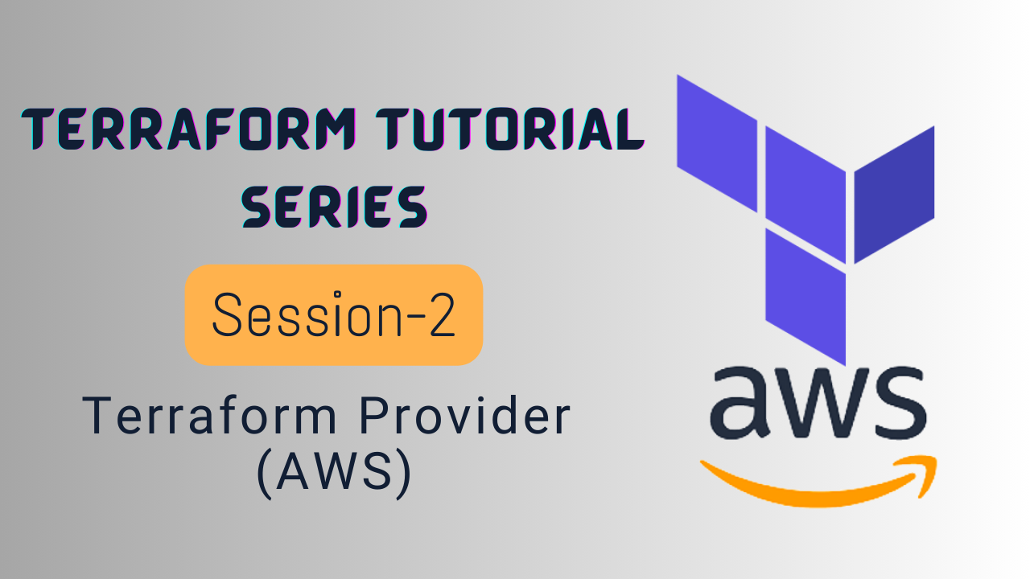
Session 2: Terraform Provider Configuration
1. Introduction to Terraform AWS Provider
- Overview of the Terraform AWS Provider
- Understanding the role of providers in Terraform
- Prerequisites for using the AWS provider (AWS account, IAM credentials)

2. Configuring the AWS Provider
- Writing a basic provider block in Terraform:
  - Specifying the aws provider
  - Setting the AWS region
  - Configuring credentials (e.g., access key, secret key)

3. Creating a Basic Terraform Configuration
- Writing a simple Terraform configuration file:
  - Defining the provider
  - Initializing Terraform with terraform init

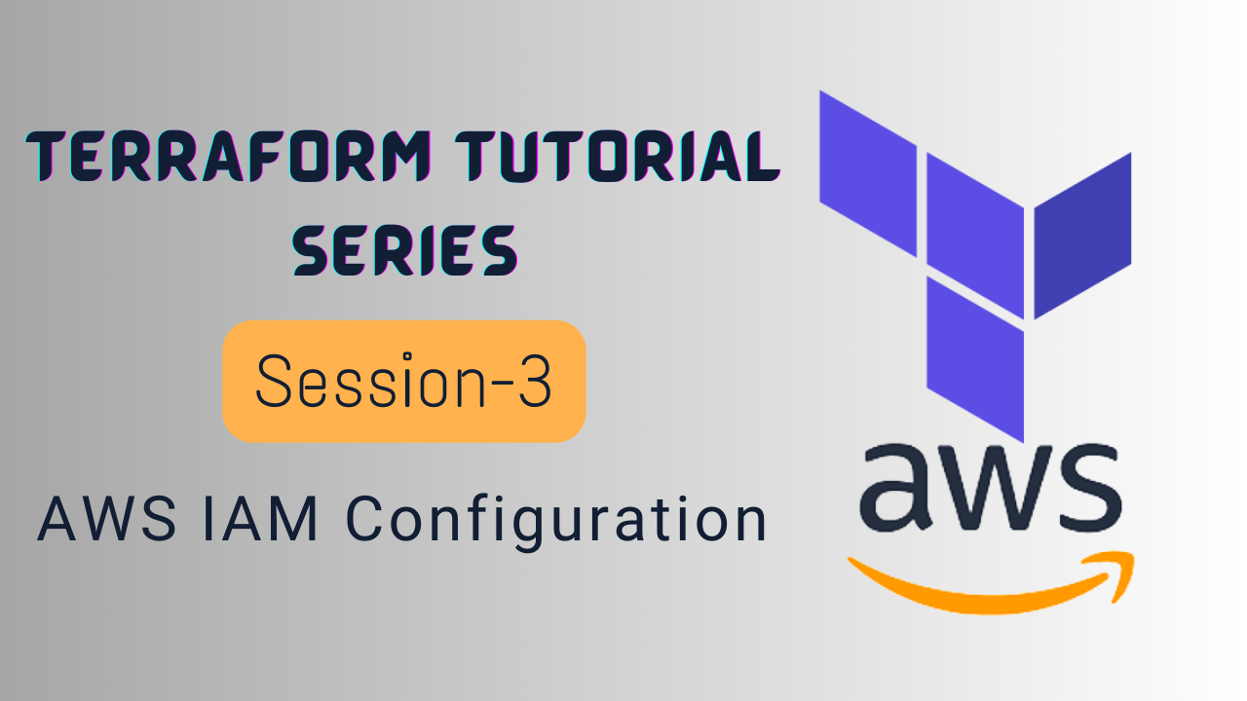
Session 3: AWS IAM Configuration
1. Introduction to AWS IAM and Terraform
- Overview of AWS Identity and Access Management (IAM)
- Importance of IAM users in AWS
- Benefits of managing IAM users with Terraform
2. Pre-Requisites for IAM User Configuration
- AWS account setup
- Terraform installed and configured locally
- Basic understanding of AWS and Terraform provider configuration
3. Create IAM user, Attach Policies and Create Keys
- Create IAM User on AWS
- Attach permissions/policies to IAM User
- Create Assess-Key and Secret-Key for IAM User
4. Configuring the AWS Provider
- Writing the provider block in Terraform
  - Specifying AWS region
  - Authentication methods (environment variables, IAM roles, etc.)
- Initializing Terraform with terraform init
5. Hands-On Lab
- Step-by-step creation of an IAM user and access key
- Attaching a policy for IAM User
- Crate and Add Assess-Key and Secret-Key for IAM User in Terraform Script (main.tf)

